# Form candidate ZIB

## When registering at the ZIB-centre, at least these 3 sections of the ZIB must be completed in both Dutch and English. Any other information (including visualizations) can be added at the end of this document.

|  |
| --- |
| Clinical Notes are the structured and unstructured representation of a provider’s observations, |
| thoughts, plans for patient care, and other general concepts that provide narrative context for |
| the provider’s interaction with the patient. |

1.1 Concept  
*Describe the content of the concept.*

***Functional status example***

*Functional Status is about aspects of the patient's functioning that are relevant to the transfer for the continuity of care around the patient.*

1.3 Purpose  
*As short and clear as possible description of the purpose of the concept described in the building block.*

|  |
| --- |
| A clinical note provides additional context about the provider’s reasoning for their care |
| decisions and helps to aid in creating seamless transitions of care between providers and |
| different care settings. The concept of a clinical note encompasses many note types, such as |

nursing notes, ED notes, OR notes, etc.

***Example treatment goal***

*A treatment goal is defined to indicate the intention of the treatment/intervention. This gives an indication of the actions to be taken as part of the care process. This also makes it possible to monitor the developments surrounding the patient's state of health for the desired care result.*

1.4 Patient Population  
*Description of the group of patients to which the building block applies.*

|  |
| --- |
| This building block applies to all patients. |
|  |
|  |

***Example ApgarScore***

*The ApgarScore building block is intended for children up to the age of 12 months.*

## 1.5 Other required information for the candidate ZIB to be submitted

|  |  |
| --- | --- |
| **Name**  *Desired name of the ZIB.* | Clinical Note |
| **Unique**  *Only if a candidate does not already exist can it be filled in as a candidate. If there is a 'structure ZIB' such as 'general measurement' but there is a need for it to be fleshed out as a candidate ZIB, you can describe here why this candidate ZIB should exist.* | This is a unique ZIB. |
| **Purpose**  *Indicate the purpose (of the project or submitter) why this ZIB is important to develop and include.* | Feedback from clinicians consistently shows that clinical notes are the most useful components of exchanged documents. In order to ensure that clinicians are able to get the most from the documents they receive from other organizations, notes should be included in exchanged documents. This ZIB will enable the exchange of these notes and help drive clinicians to make well informed decisions regarding patient care. |
| **Match with field**  *Indicate which alignment has already taken place or is necessary to complete the candidate's ZIB after prior notice.* |  |
| **Information Model**  *This can be done in any form. A visualization, mind map or an Excel file listing the concept elements.* | See below for a sample mind map. This was designed based on the work done by HL7 for the C-CDA Note Activity. We recommend reviewing the work done on the C-CDA Note Activity for defining the information model, and the resulting implementation of the information model. The C-CDA Note Activity structure is currently in use in the United States and has helped to improve note interoperability in that space. |
| **Contact person**  *If this is a person other than the applicant, enter the name of this person here.* |  |

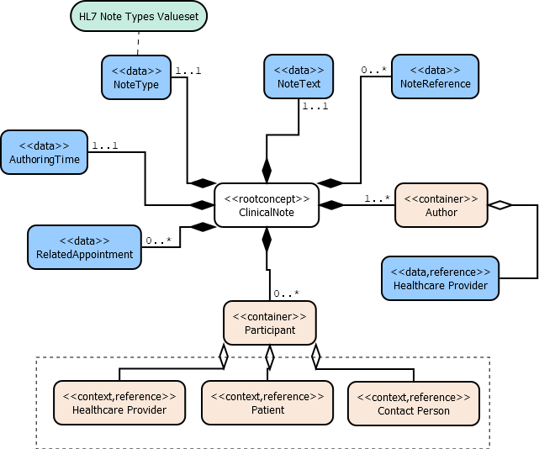

|  |  |  |
| --- | --- | --- |
| Concept | Card. | Definition |
| NoteType | 1..1 | The type of note that is represented by the specific note construct. Examples of this would be a progress note, a nursing note, a history and physical note, etc. We suggest using the codes defined in the LOINC document ontology to represent the note type. |
| NoteText | 1..1 | The free-text content of the note that comprises of the author’s thoughts and observations. The content included here should be appropriate for the type of note represented. |
| NoteReference | 0..* | Any references to external sources that comprise the note content. |
| AuthoringTime | 1..1 | The date and time at which the note was written. |
| RelatedAppointment | 0..* | Any contacts which should be associated with the note. Typically the contact during which the note was written would be included here, along with contacts from which the data in the note was pulled. |
| Author | 1..* | The caregiver that wrote the note, along with any others that assisted in writing the note. |
| * HealthcareProvider |  | The caregiver ZIB that should be referenced when filling in information for the author. |
| Participant | 0..* | Any person that is connected with the note. Examples: the patient the note is about, the providers that interacted with the patient within the context of the note, the patient contact that needs to be informed of the information in the note, etc. |
| * HealthcareProvider |  | The caregiver ZIB that should be referenced when filling in information for this component. |
| * Patient |  | The patient ZIB that should be referenced when filling in information for this component. |
| * ContactPerson |  | The contact person ZIB that should be referenced when filling in information for this component. |